**Lab 2**

**Galen J. Yanofsky**

**SDEV 400 7981**

**Dr. James Robertson**

**19 November 2017**

1. Using your non-root, admin AWS account, create a S3 bucket named SDEV400HW2YourName that includes 4 folders for labeled: Students, Faculty, Admin, Presentations.

The account I logged into is a non-root account

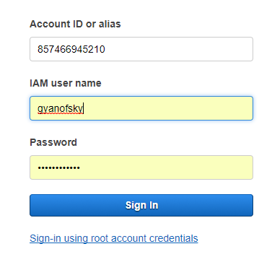

The user account and region are listed in the upper-right corner of the webpage



I then create a bucket with a DNS compliant name of edu.umuc.sdev400.hw2.yanofsky.

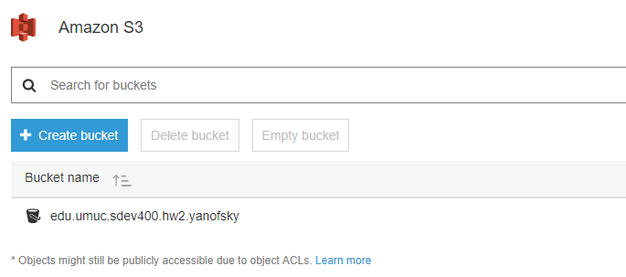

In the bucket, I create the four folders.

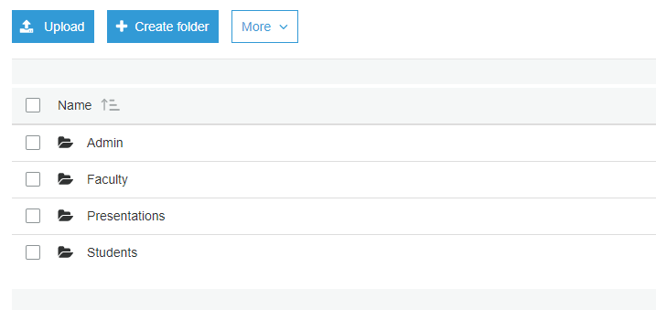

1. Write a batch file that copies 4 files to each folder in the S3 bucket. Demonstrate a working batch script.

The following script was created to copy the following files from my local computer to my online AWS S3 bucket. The bucket is titled edu.umuc.sdev400.hw2.yanofsky. The bucket contains four folders. The original batch script was created in Notepad++. The local folder which the script copies from is shown below.

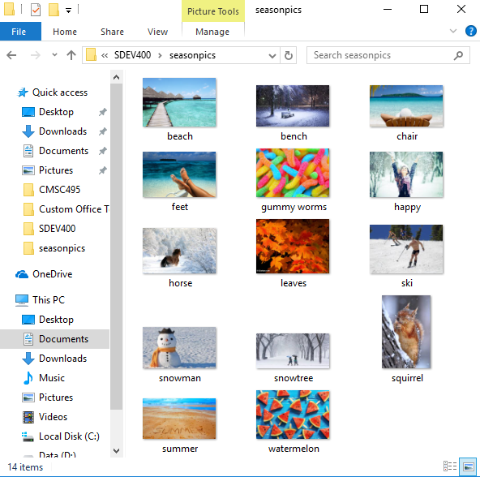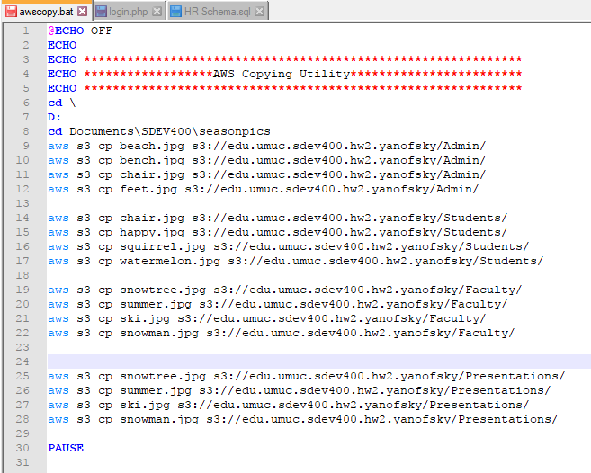  
When the script is executed, the following command prompt terminal appears on the screen.

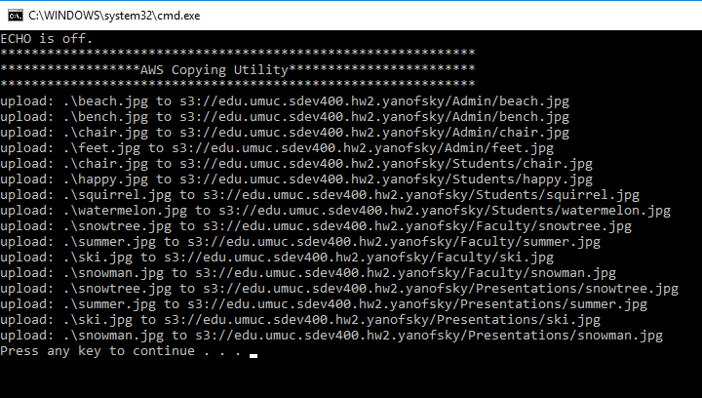

As is shown in the above prompt, each file is subsequently load the each folder. When we check the contents of the bucket we can see that each folder is now filled with the image files that were copied. For example the contents of the Admin folder is now: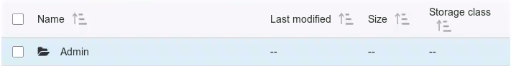

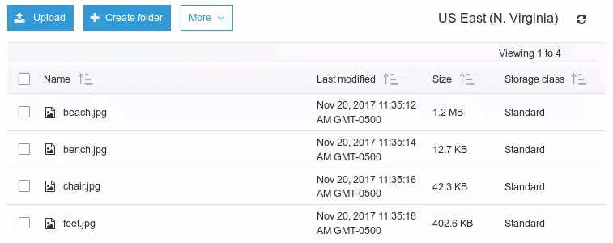

1. Create the appropriate users, groups and policies to grant permissions for list, read and write access for the S3 bucket folders. Use the table below as a reference

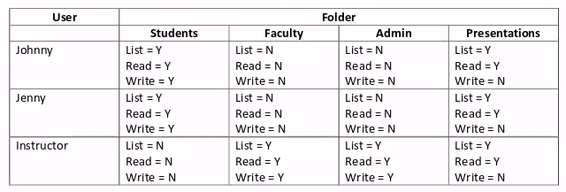

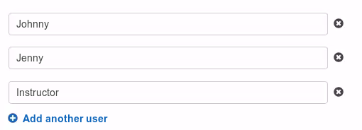I create the following users using the IAM “Add User” service.

I assign a console password that can used by these users to access multiple services and tools



